Safe Recruitment of Staff and Volunteers
All reasonable steps must be taken to ensure unsuitable people are prevented from working with children and adults at risk in Martial Arts. Whilst there may be some reservations that volunteers could be put off by having to go through a recruitment process, it is important to ensure reasonable steps have been taken to identify unsuitable individuals. The guide below offers advice on the elements that an ideal safe recruitment practise would follow.
The following steps should be carried out:
- Planning
- Advertising
- Application Form and Self Disclosure
- Interview
- References
- DBS disclosure where appropriate
- Induction
- Monitoring and Appraisal
Planning
Pre-application information should be written before the role is advertised and should contain:
• a job description, including roles and responsibilities;
• a person specification (e.g. stating qualifications or experience required);
• a self-disclosure form (for applicants to declare prior convictions or other potentially relevant information).
Advertising
Advertising should reflect the:
• aims of the particular programme involved;
• key responsibilities of the role;
• level of experience or qualifications required (e.g. experience of working with young people and/or adults at risk, relevant NGB qualification standard);
• the School’s/academies open and positive stance on child protection and equal opportunities;
• need for a satisfactory reference/background checks (e.g. enhanced DBS disclosure).
Applications
All applicants who will work with young people and/or adults at risk, whether for paid or voluntary, should complete a self-declaration form. If the role meets the eligibility criteria for ‘regulated activity’, then the form should ask if they are barred from working (including volunteering) with children.
Interview, References and Disclosure
An interview should take place for positions involving working with children and/or adults at risk. This also provides an ideal opportunity to view certificates to confirm qualifications held.
Once a successful candidate is chosen, they should be asked to complete a self-disclosure form and offered the role subject to satisfactory references and vetting checks. A minimum of two references should be requested; ideally at least one should be associated with former work with children and/or adults at risk.
If the role is in ‘regulated activity’ then an enhanced DBS disclosure with barring check must be completed. See Disclosure and Barring Service Guidance.
The same emphasis should be placed on ensuring that volunteers are vetted as for paid employees.
Induction
All staff and volunteers should undergo an induction which should include:
- Information about the safeguarding policy and procedures;
- That their qualifications are substantiated (if not already completed);
- That they complete a profile to identify training needs/aspirations;
- That they are reminded that they have agreed to abide by the NGB/School/Academy policies and procedures and they may face disciplinary action if they are broken;
- The expectations, roles and responsibilities of the job are clarified
- Mentoring where appropriate.
Checks are only part of the process to protect children and/or adults at risk from possible abuse. Appropriate training will enable individuals to recognise their responsibilities with regard to their own good practice and the reporting of suspected poor practice/concerns of possible abuse.
International Instructors
There can be different cultural practices and behaviours around coaching in different countries. It is imperative that International instructors are given a full induction into the behaviour and conduct expected of instructors in the UK. They should also sign an Instructors Code of Ethics and Conduct.

Monitoring and appraisal
At regular intervals (or following a particular programme), employees/volunteers working with children and/or adults at risk should be given the opportunity to receive feedback or an appraisal to identify training needs and set new goals.
Additional Information
Whilst intended for Schools, further advice can be found at Part Three of Keeping children Safe in Education 2018, the document can be found on the following link:
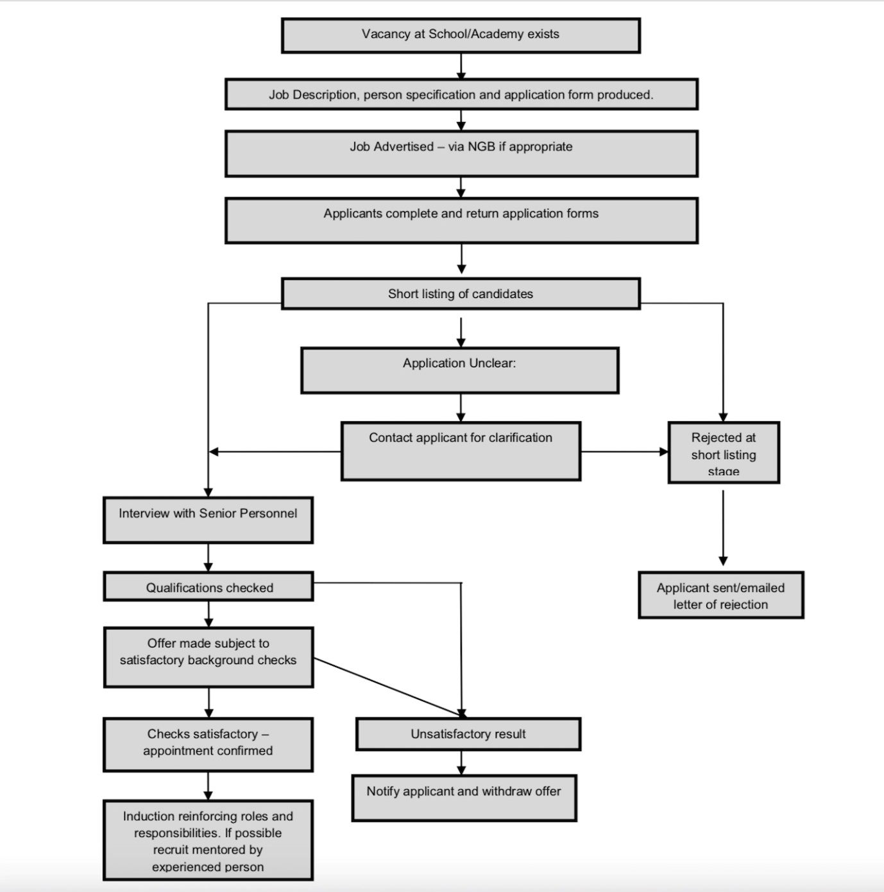
https://assets.publishing.service.gov.uk/government/uploads/system/uploads/attachment_data/file/550511/Keeping_children_safe_in_education.pdf
Safer Recruiting Process Chart

